1. How many Namespaces exist on the system?

Kubectl get namespaces

1. How many pods exist in the kube-system namespace?

Kubectl get pod -n kube-system

1. Create a deployment with

Name: beta

Image: redis

Replicas: 2 Namespace: finance Resources Requests:

CPU: .5 vcpu

Mem: 1G

Resources Limits:

CPU: 1 vcpu

Mem: 2G

Answer :

Kubectl create namespace finance

Vim app2.yaml

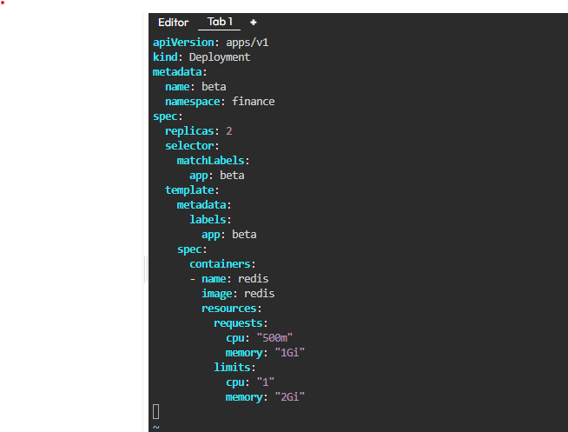

1. How many Nodes exist on the system?

kubectl get nodes

1. Do you see any taints on master?

kubectl describe nodes controlplane

1. Apply a label color=blue to the master node

kubectl label node controlplane color=blue

kubectl get nodes --show-labels

1. Create a new deployment named blue with the nginx image and 3 replicas

Set Node Affinity to the deployment to place the pods on master only

NodeAffinity: requiredDuringSchedulingIgnoredDuringExecution Key: color values: blue

